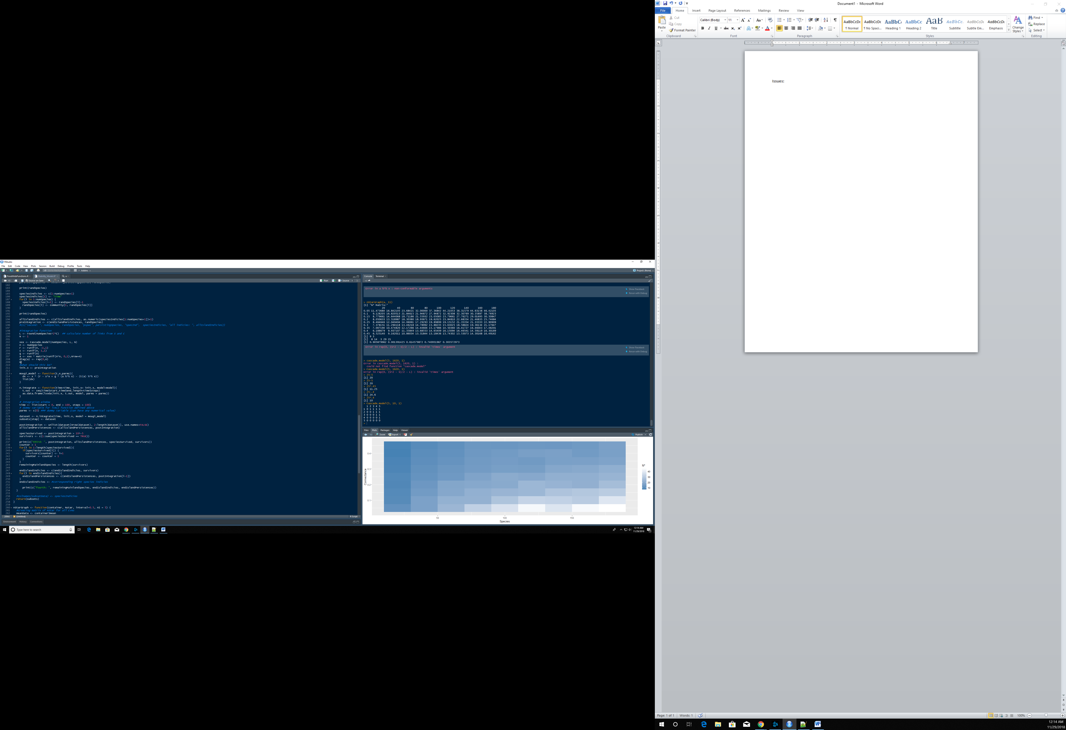Issues:

The issue here is that at a connectance of 0.45 and a species count of 5, an error is thrown by the cascade model. This is because the L value is larger than the first term in the rep() function. At larger numbers this will not matter, but at smaller values (smallest possible of 1) it will fail. My suggested solution would be to have it take some alternative course of action when this error is thrown (such as not running), but I need to know what’s happening here from a biological standpoint to understand it.

Strange behavior in the community integration; I noticed that the surviving species are consistently 1,2,3, etc. I would expect these to be randomly distributed such that higher species survived too, but there may be a biological explanation. Need more info before taking action.

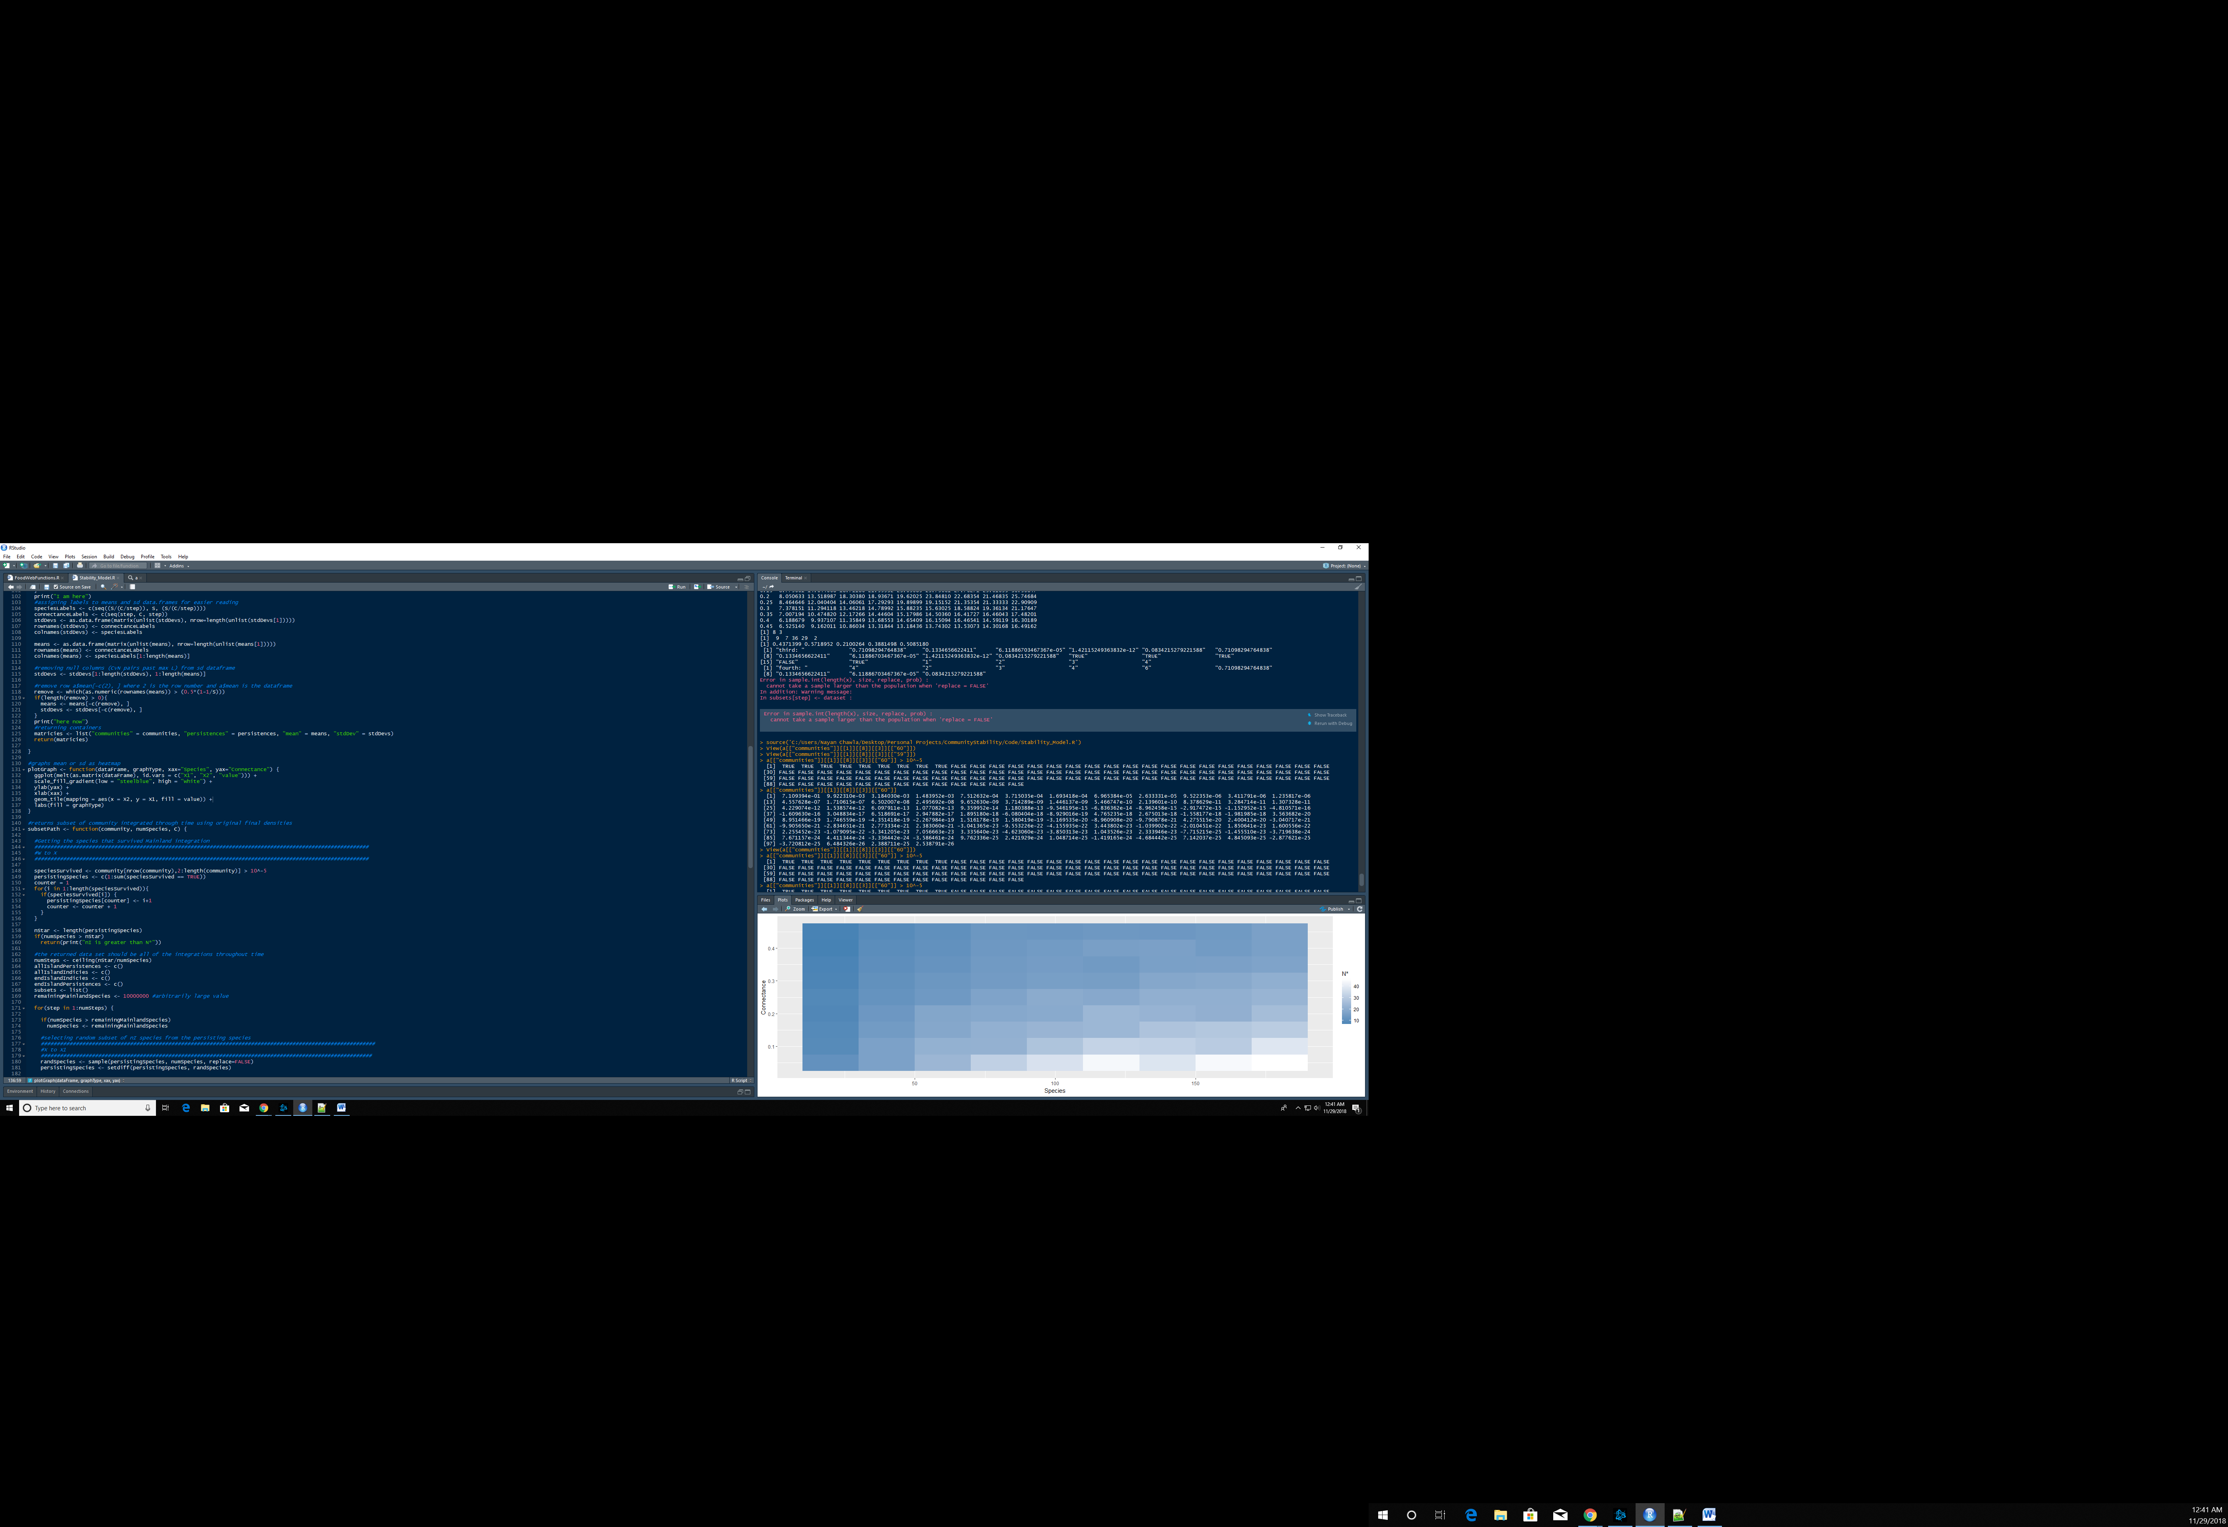

Solution: Thinking about this incorrectly! This is the integration of species number 60 through time, not all 60 species.

Very confused; Where are the values in randSpecies coming from? I looked for the values it lists as having been obtained from replicate 1, 8, 3 (29, 36, etc.) and none of them exist, much less at the index listed. I will likely rewrite this code but I wanted a record just in case.

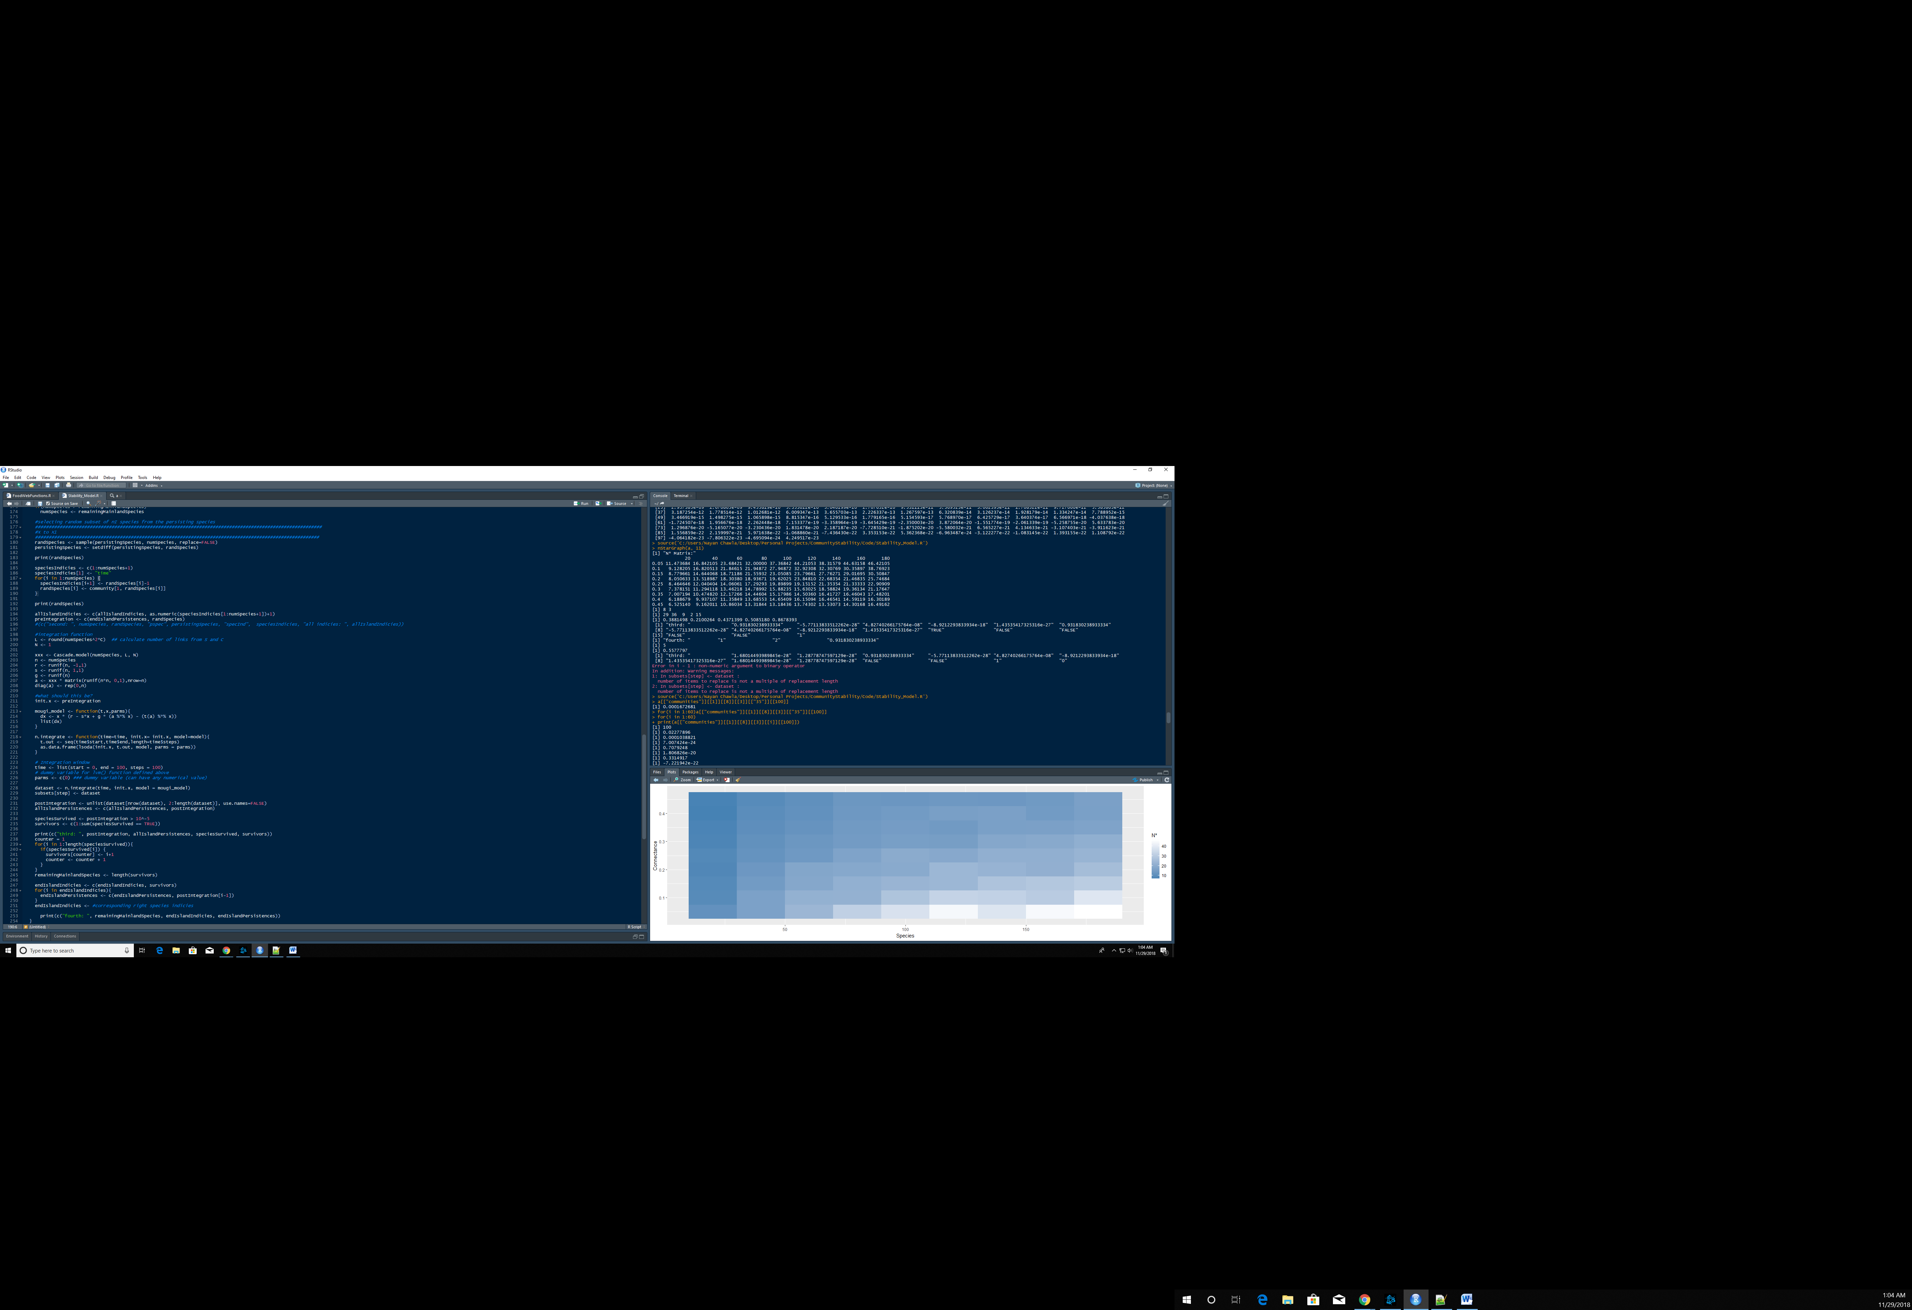Edit: The species it lists (29, 36, etc.) shifted down by 1 (so 28, 35, etc.) are all persisting. However, the values for those species are not the same and are not contained within the community. So it is definitely an error present in the assignment code.

Solution: Look at the green box; I was using 1 as the row to select from instead of 100. So that explains that, although I wonder if this was an error or something I’m forgetting.